**Practical 10**

**Aim**: To implement a program for pricing table is a way for representing pricing schemes, features and categories of products in a website. (Mostly pricing table is used for showing different kinds of plans and packages by companies. Users can easily compare prices between different packages from lists of pricing columns and choose best plan that suit for their business.) Design a web page to show pricing table with 4 color themes.

**Theory:**

A basic Bootstrap table has a light padding and only horizontal dividers. The .table class adds basic styling to a table:

Example

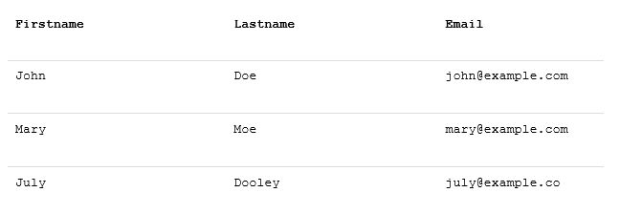

Bordered Table

The .table-bordered class adds borders on all sides of the table and cells:

Example

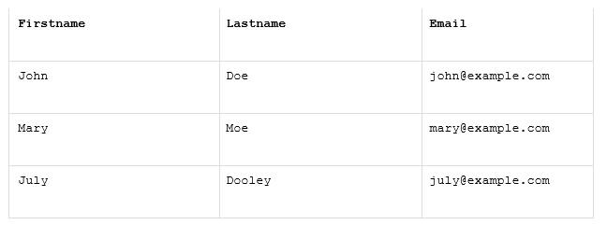

**INPUT**

<html>

<head>

<title>Pricing</title>

<link href="http://netdna.bootstrapcdn.com/bootstrap/3.2.0/css/bootstrap.min.css" rel="stylesheet" id="bootstrap-css">

<link href="style.css" rel="stylesheet">

<style>

@import url(http://fonts.googleapis.com/css?family=Open+Sans:300);

.price_table_container{

text-align:center;

color:#666;

margin-top:35px;

font-family: 'Open Sans', sans-serif;

}

.price_table_heading{

font-size:36px;

padding:10px;

background:#EEE;

}

.price_table_row {

padding:15px;

background: #FFF;

}

.cost{

padding:30px;

font-size:30px;

}

.price_table_row:nth-of-type(even) {

background: #F8F8F8;

}

.btn{

border-radius:0px;

}

.recommended{

/*USER DEFINED COLOUR*/

background:#FF3A3A;

color:#FFF;

/*USER DEFINED COLOUR*/

padding:3px 0 3px 0;

margin-top:10px;

text-align:center;

margin-bottom:-35px;

font-family: 'Open Sans', sans-serif;

}

.primary-bg{background:#337AB7;color:#FFF;}

.success-bg{background:#5CB85C;color:#FFF;}

.info-bg{background:#5BC0DE;color:#FFF;}

.warning-bg{background:#F0AD4E;color:#FFF;}

</style>

<body>

<div class="container">

<h2><center>Hosting Plans By Different Companies</center></h2>

<div class="row">

<div class="col-md-3 col-sm-6 col-xs-12 float-shadow">

<div class="price_table_container">

<div class="price_table_heading">Company A</div>

<div class="price_table_body">

<div class="price_table_row cost warning-bg"><strong>Rs199</strong><span>/Month</span></div>

<div class="price_table_row">10 Websites</div>

<div class="price_table_row">100 GB Storage</div>

<div class="price_table_row">10 GB Bandwidth</div>

<div class="price_table_row">10 Email Addresses</div>

<div class="price_table_row">Free Backup</div>

<div class="price_table_row">Full Time Support</div>

</div>

<a href="#" class="btn btn-warning btn-lg btn-block">Sign Up</a>

</div>

</div>

<div class="col-md-3 col-sm-6 col-xs-12 float-shadow">

<div class="recommended"><strong><span class="glyphicon glyphicon-heart"

aria-hidden="true"></span> RECOMMENDED</strong></div>

<div class="price_table_container">

<div class="price_table_heading">Company B</div>

<div class="price_table_body">

<div class="price_table_row cost primary-bg"><strong>Rs299</strong><span>/Month</span></div>

<div class="price_table_row">10 Websites</div>

<div class="price_table_row">100 GB Storage</div>

<div class="price_table_row">100 GB Bandwidth</div>

<div class="price_table_row">50 Email Addresses</div>

<div class="price_table_row">Free Backup</div>

<div class="price_table_row">Full Time Support</div>

</div>

<a href="#" class="btn btn-primary btn-lg btn-block">Sign Up</a>

</div>

</div>

<div class="col-md-3 col-sm-6 col-xs-12 float-shadow">

<div class="price_table_container">

<div class="price_table_heading">Company C</div>

<div class="price_table_body">

<div class="price_table_row cost success-bg"><strong>Rs449</strong><span>/Month</span></div>

<div class="price_table_row">10 Websites</div>

<div class="price_table_row">10 GB Storage</div>

<div class="price_table_row">100 GB Bandwidth</div>

<div class="price_table_row">100 Email Addresses</div>

<div class="price_table_row">Free Backup</div>

<div class="price_table_row">Full Time Support</div>

</div>

<a href="#" class="btn btn-success btn-lg btn-block">Sign Up</a>

</div>

</div>

<div class="col-md-3 col-sm-6 col-xs-12 float-shadow">

<div class="price_table_container">

<div class="price_table_heading">Company D</div>

<div class="price_table_body">

<div class="price_table_row cost info-bg"><strong>Rs349</strong><span>/Month</span></div>

<div class="price_table_row">10 Websites</div>

<div class="price_table_row">10 GB Storage</div>

<div class="price_table_row">100 GB Bandwidth</div>

<div class="price_table_row">1000 Email Addresses</div>

<div class="price_table_row">Free Backup</div>

<div class="price_table_row">Full Time Support</div>

</div>

<a href="#" class="btn btn-info btn-lg btn-block">Sign Up</a>

</div>

</div>

</div>

</div>

<script src="http://code.jquery.com/jquery-1.10.2.min.js"></script>

<script

src="http://netdna.bootstrapcdn.com/bootstrap/3.2.0/js/bootstrap.min.js"></script>

</body>

</html>

**OUTPUT**

